|  |  |
| --- | --- |
| TEACHER | |
| **Teacher ID** | Name |
| 1 | Asem |
| 2 | John |
| 3 | Valeria |
| 4 | Hardeep |

|  |  |
| --- | --- |
| COURSE | |
| **Code** | Desc. |
| A | DB |
| B | CC |
| C | C++ |
| D | Java |

|  |  |
| --- | --- |
| TEACHER | |
| **Teacher ID** | Name |
| 1 | Asem |
| 2 | John |
| 3 | Valeria |
| 4 | Hardeep |

Solution: create a Junction Table

|  |  |
| --- | --- |
| TEACHER_COURSES | |
| **Teacher ID** | **Course ID** |
| 1 | A |
| 1 | B |
| 2 | A |
| 2 | C |
| 3 | D |
| 3 | A |
| 4 | B |

|  |  |
| --- | --- |
| COURSE | |
| **Code** | Desc. |
| A | DB |
| B | C++ |
| C | BD |
| D | Java |

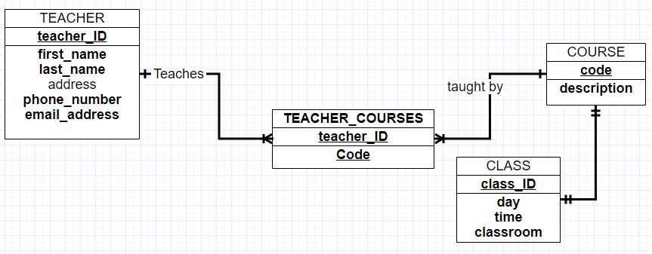ER_Diagram: